Introduction to Data analysis CA





Student Number:X19220456

Student Name: Cheong Hao Io

Due Date: 23-April-2020

**Online jewellery retail business** – *Krie*

Business contexts

Business ERD Diagram 3

Product Category 4

Database creation 8

Inserting Value into the tables 10

CA Questions 15

Q1 Sales transactions for pasted 12 weeks in the business 15

In DataMart 15

Q2 Create a trigger that represent the stock levels when a sales order takes place 18

Q3 Purchased stocks from suppliers 22

In DataMart 22

Q4 Total stock sold to general public (group by supplier) 23

Q5 Total Sales transection month to date (start from March) 25

Q6. Total Sales transection year to date 2020 26

Q7. Monthly breakdown for 2019 26

Q8. Growth rate % from 2019 to now 27

*Additional* - Stored procedures 27

References 29

# Business ERD Diagram

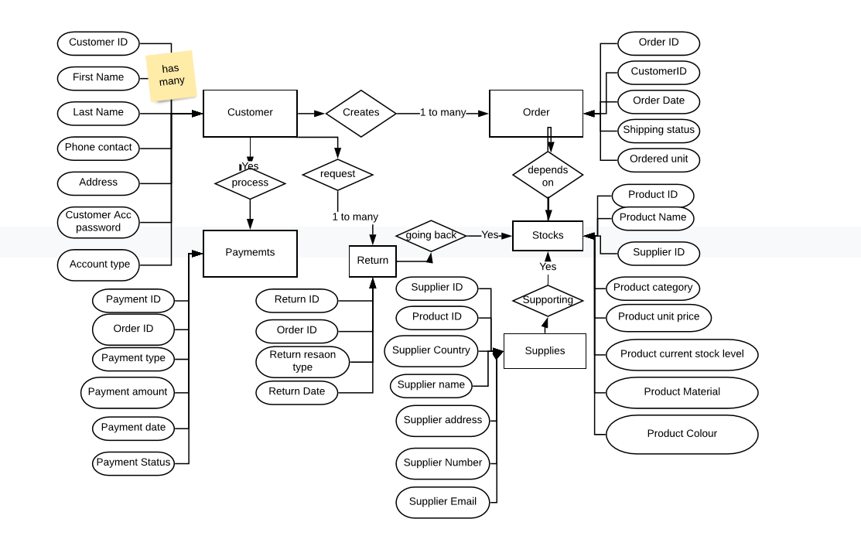

# Product Category

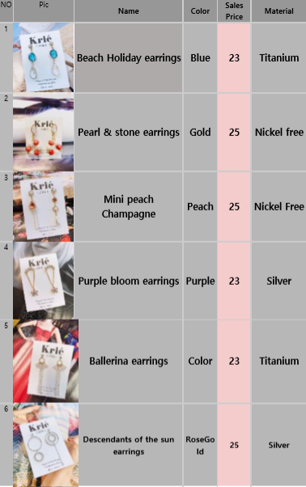

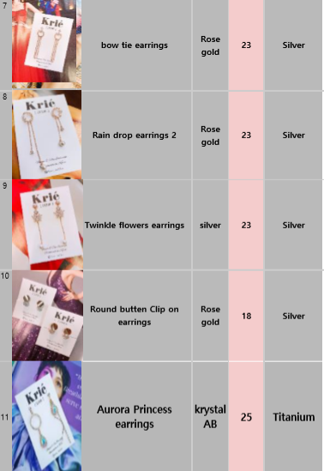

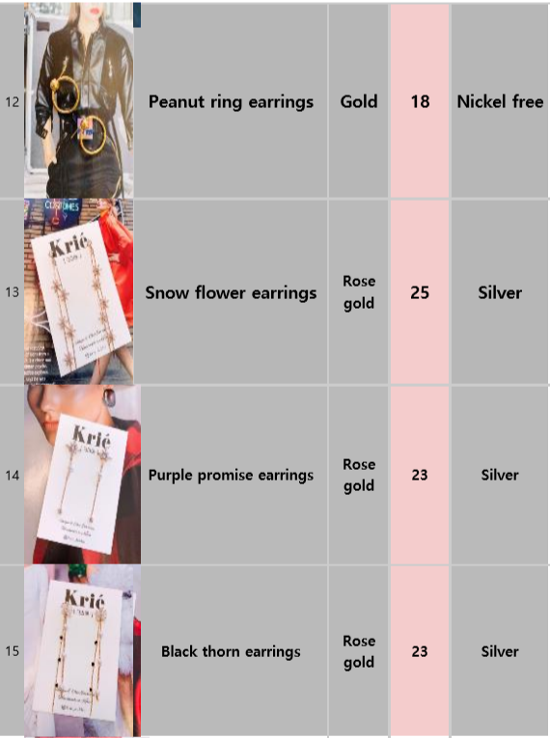

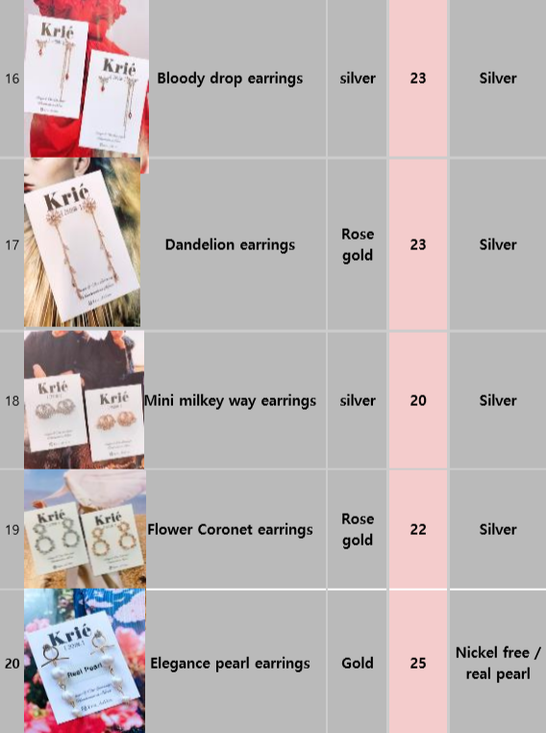

# Database creation

CREATE DATABASE Krie;

USE Krie;

CREATE TABLE Customer (

CustomerID varchar(100),

FirstName varchar(100),

LastName varchar(100),

Address varchar(255),

Country varchar(100),

Mobile varchar(100),

Customer_Account_Password varchar(250),

Account_Type varchar(100),

PRIMARY KEY (CustomerID)

);

CREATE TABLE Orders (

OrderID varchar(100),

CustomerID varchar(100),

Order_Date date,

Shipping_Status varchar(100),

PRIMARY KEY (OrderID)

);

CREATE TABLE Payment (

PaymentID varchar(100),

OrderID varchar(100),

Payment_Type varchar(100),

Payment_Amount varchar(100),

Payment_Date datetime,

Payment_Status varchar(100),

PRIMARY KEY (PaymentID)

);

CREATE TABLE Stock (

ProductID varchar(100),

SupplierID varchar(100),

Product_Name varchar(100),

Product_Category varchar(100),

Product__Colour varchar(100),

Product_Material varchar(100),

Product_Unit_Price varchar(100),

Product__Stock_Level varchar(100),

PRIMARY KEY (ProductID)

);

CREATE TABLE Supplies (

SupplierID varchar(100),

Supplier_Name varchar(100),

Supplier_Address varchar(250),

Supplier_Country varchar(100),

Supplier_Number varchar(100),

Supplier_Email varchar(250),

PRIMARY KEY (SupplierID)

);

CREATE TABLE Returnings (

ReturnID varchar(100),

OrderID varchar(100),

Return_Reason_Type varchar(100),

Return_Date date,

PRIMARY KEY (ReturnID)

);

## Inserting Value into the tables

INSERT INTO

Customer (CustomerID,FirstName,LastName,Address,Country,Mobile,Customer_Account_Password, Account_Type)

VALUES

('101','Kate','Murphy','41 Little Strand Street','Ireland', '0831223456','20200104','General'),

('102','Pablo','Caracol','61 La calle feliz','Spain','0034831952312','iyayayaya','Subscription'),

('103','Miko','Cheong','1 Happy Street','Ireland','0821313242','okepsdf','General'),

('105','Vivian','Chan','33 Big long Street','Ireland', '0872312345','whaticansay','Subscription'),

('106','Crystal','Murphy','76 Ballyformot Street','Ireland', '0831296253','crystalc','General'),

('107','Poey','Po','21 The middle Street','Ireland', '0831666253','catfish','General'),

('108','Pablo','Roca','88 Ballybough Avenue','Ireland', '0831254234','AAnotgood','General'),

('109','Mika','Murphy','65 Grand Canal Avenue','Ireland', '0859543243','mikami','Subscription'),

('110','Alice','P','7 Wonderland Avenue','Korea','00383245623','Magic123','Subscription'),

('111','Carmen','Molina','78 La calle triste','Spain','0034859543243','carmen01','General'),

('112','Sergio','Molina','80 La calle triste','Spain','0034859543243','sergio000','General'),

('113','Ivan','Murphy','1 Little Strand Street','Ireland', '0831999236','Ivanivan','Subscription'),

('114','Sherry','King','67 Low Avenue','Ireland', '0891923333','SherryK','General'),

('115','Allen','G','Mallow Lower Avenue','Ireland', '0892212555','AllenG','General'),

('116','Mary','Mcknight','163 Tullow Road','Ireland', '0852232155','MaryKnight','General'),

('117','Cody','OBrien','166 Abbey Street','Ireland', '098231223','Cody12356','General'),

('118','Sabrina','Hsiao','Rathma Road','Ireland', '0832235557','CoolBean','Subscription');

INSERT INTO

Stock (ProductID,SupplierID,Product_Name,Product_Category,Product__Colour,Product_Material,Product_Unit_Price,Product__Stock_Level)

VALUES

('1','30001','Beach Holiday earrings','Daily','Blue','Titanium ','23','11'),

('2','30001','Pearl & stone earrings','Daily','Gold','NickelFree','25','14'),

('3','30002','Mini peach Champagne','Special Occasion','Peach','NickelFree','25','12'),

('4','30004','Purple bloom earrings','Special Occasion','Purple','Sliver','23','8'),

('5','30001','Ballerina earrings','Special Occasion','Clear','Titanium ','23','10'),

('6','30005','Descendants of the sun earrings','Classic','RoseGold','Silver','25','13'),

('7','30005','bow tie earrings','Classic','RoseGold','Silver','23','13'),

('8','30004','Rain drop earrings 2','Classic','RoseGold','Silver','23','7'),

('9','30005','Twinkle flowers earrings','Classic','Silver','Silver','23','6'),

('10','30001','Round butten Clip on earrings','Causal','RoseGold','Silver','18','9'),

('11','30002','Aurora Princess earrings','Special Occasion','krystalAB','Titanium','25','13'),

('12','30005','Peanut ring earrings','Causal','Gold','NickelFree','18','7'),

('13','30005','Snow flower earrings','Classic','RoseGold','Silver','25','6'),

('14','30003','Purple promise earrings','Classic','RoseGold','Silver','23','14'),

('15','30003','Black thorn earrings','Classic','RoseGold','Silver','23','8'),

('16','30003','Bloody drop earrings','Daily','Silver','Silver','23','10'),

('17','30002','Dandelion earrings','Classic','RoseGold','Silver','23','11'),

('18','30004','Mini milkey way earrings','Daily','Silver','Silver','20','15'),

('19','30004','Flower Coronet earrings','Daily','RoseGold','Silver','22','7'),

('20','30004','Elegance pearl earrings','Daily','Gold','RealPearl','25','6');

INSERT INTO

Supplies (SupplierID,Supplier_Name,Supplier_Address,Supplier_Country,Supplier_Number,Supplier_Email)

VALUES

('30001','Moonyang Studio','Sannam-ro, Yeongtong-gu Suwon-si, Gyeonggi-do','Korea','00821030575115','moonyangstudio.en.ec21.com'),

('30002','TYT Inc','36-12, Toegye-ro 6ga-gil Jung-gu, Seoul','Korea','00821036496495','wolgan.en.ec21.com'),

('30003','Heyshop','The Western of the South Ring, Dongming Community,Yuzhou District, Yulin City, Guangxi Province','China','00867752818295','heyshop999.en.ec21.com'),

('30004','Lifect Center','21, Hwangsaeul-ro 360beon-gil,Seongnam-si Bundang-gu, Gyeonggi-do, Seoul','Korea','00821098806470','lifectcenter.en.ec21.com'),

('30005','KK trading','84, Seocho-daero 4-gil, Seocho-gu,Seoul','Korea','008215973949','nokchawon.co.kr');

INSERT INTO

orders (OrderID,CustomerID,Order_Date,Shipping_Status)

VALUES

('T110','102','2020-3-01','Shipped'),

('T111','106','2020-2-11','Shipped'),

('T113','107','2020-3-26','Pending'),

('T114','110','2020-04-02','Pending'),

('T115','115','2020-01-01','Received'),

('T116','118','2020-03-25','Shipped'),

('T117','103','2020-02-25','Shipped'),

('T118','101','2020-03-29','Pending'),

('T119','103','2020-02-15','Shipped'),

('T120','104','2020-01-15','Received'),

('T121','109','2020-01-22','Received'),

('T122','102','2019-07-15','Received'),

('T123','101','2019-05-30','Received'),

('T124','103','2019-08-30','Received'),

('T125','106','2019-09-13','Received'),

('T126','108','2019-10-07','Received'),

('T127','109','2019-11-01','Received'),

('T128','112','2019-11-11','Received'),

('T130','118','2019-12-24','Received'),

('T131','117','2019-12-22','Received'),

('T132','115','2019-04-22','Received'),

('T133','114','2019-05-22','Received'),

('T134','112','2019-06-27','Received'),

('T135','112','2019-08-27','Received'),

('T136','110','2019-08-08','Received'),

('T137','103','2019-01-19','Received'),

('T138','105','2020-02-02','Shipped'),

('T139','109','2020-03-15','Shipped'),

('T140','104','2020-03-22','Shipped'),

('T141','107','2020-03-28','Shipped');

INSERT INTO

payment (PaymentID,OrderID,Payment_Type,Payment_Amount,Payment_Date,Payment_Status)

VALUES

('00010','T110','VisaDebit','50','2020-01-03','Approved'),

('00011','T111','Paypal','46','2020-2-11','Approved'),

('00012','T113','Voucher','52','2020-3-26','Approved'),

('00013','T114','VisaDebit','36','2020-04-02','Declined'),

('00014','T115','Paypal','44','2020-01-01','Approved'),

('00015','T116','VisaDebit','48','2020-03-25','Approved'),

('00016','T117','VisaDebit','50','2020-02-25','Approved'),

('00017','T118','VisaDebit','46','2020-03-29','Approved'),

('00018','T119','Paypal','54','2020-02-15','Approved'),

('00019','T120','Paypal','44','2020-01-15','Approved'),

('00020','T121','Paypal','46','2020-01-22','Approved'),

('00021','T122','Paypal','50','2019-07-15','Approved'),

('00022','T123','Paypal','48','2019-05-30','Approved'),

('00023','T124','VisaDebit','50','2019-08-30','Approved'),

('00024','T125','VisaDebit','44','2019-09-13','Approved'),

('00025','T126','VisaDebit','52','2019-10-07','Approved'),

('00026','T127','VisaDebit','52','2019-11-01','Approved'),

('00027','T128','Paypal','54','2019-11-11','Approved'),

('00028','T130','Paypal','48','2019-12-24','Approved'),

('00029','T131','Paypal','52','2019-12-22','Approved'),

('00030','T132','Paypal','44','2019-04-22','Approved'),

('00031','T133','Paypal','50','2019-05-22','Approved'),

('00032','T134','Paypal','52','2019-06-27','Approved'),

('00033','T135','VisaDebit','54','2019-08-27','Approved'),

('00034','T136','VisaDebit','52','2019-08-08','Approved'),

('00035','T137','VisaDebit','50','2019-01-19','Approved'),

('00036','T138','VisaDebit','48','2020-02-02','Declined'),

('00037','T139','Voucher','44','2020-03-15','Approved'),

('00038','T140','VisaDebit','36','2020-03-22','Approved'),

('00039','T141','VisaDebit','72','2020-03-28','Approved'),

('00040','T138','VisaDebit','48','2020-02-02','Approved'),

('00041','T114','VisaDebit','36','2020-04-02','Approved');

INSERT INTO

returnings (ReturnID,OrderID,Return_Reason_Type,Return_Date)

VALUES

('CC101','T124','Faulty','2020-09-11'),

('CC102','T126','Mismatch Product','2019-10-27'),

('CC103','T128','Mismatch Product','2019-12-01'),

('CC104','T131','Faulty','2019-12-21'),

('CC105','T131','Faulty','2019-12-21'),

('CC106','T136','Faulty','2019-08-15'),

('CC110','T111','Mismatch Product','2020-02-25');

CA questions

# CA Questions

## Q1 Sales transactions for pasted 12 weeks in the business

**Code**

USE KRIE;

CREATE VIEW RECENT_12WEEKS_TRANSECTIONS AS

SELECT *FROM PAYMENT WHERE Payment_Date>"2020-1-12"

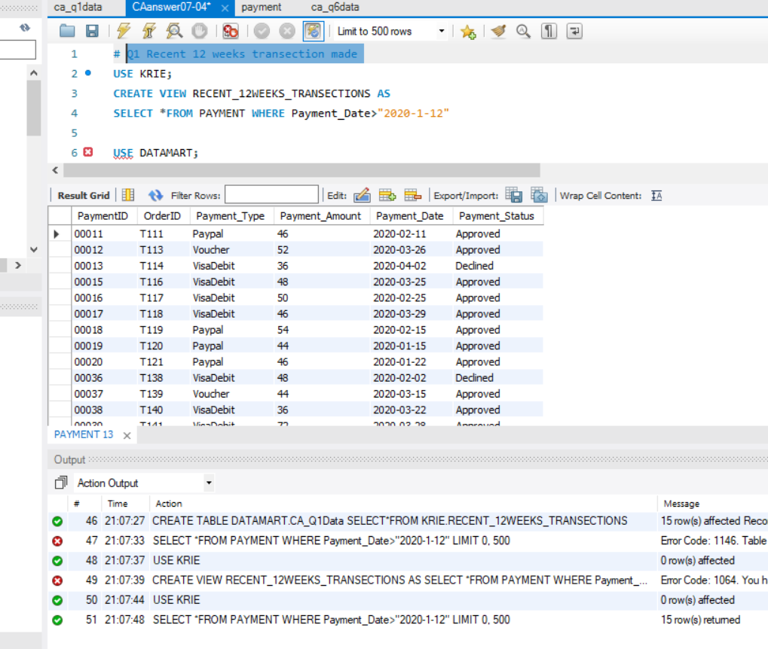

### In DataMart

**Code**

USE DATAMART;

CREATE TABLE DATAMART.CA_Q1Data

SELECT*FROM KRIE.RECENT_12WEEKS_TRANSECTIONS;

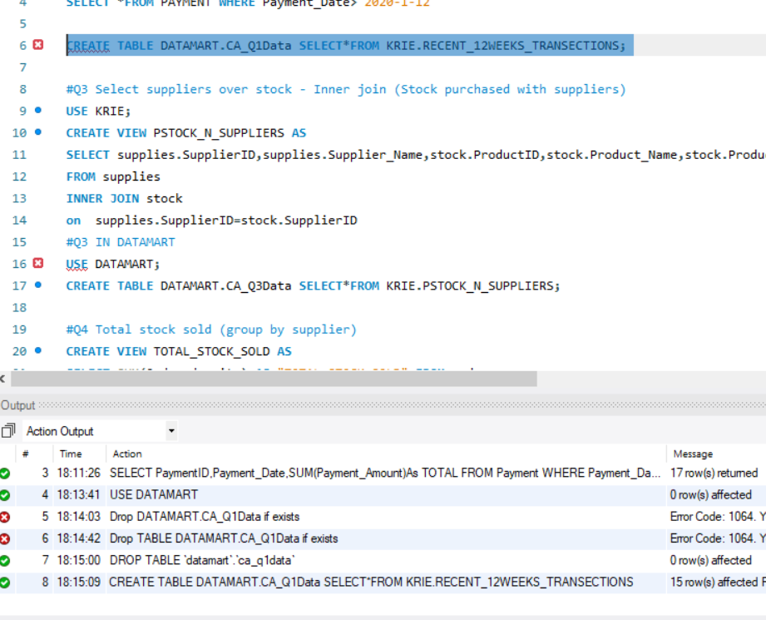

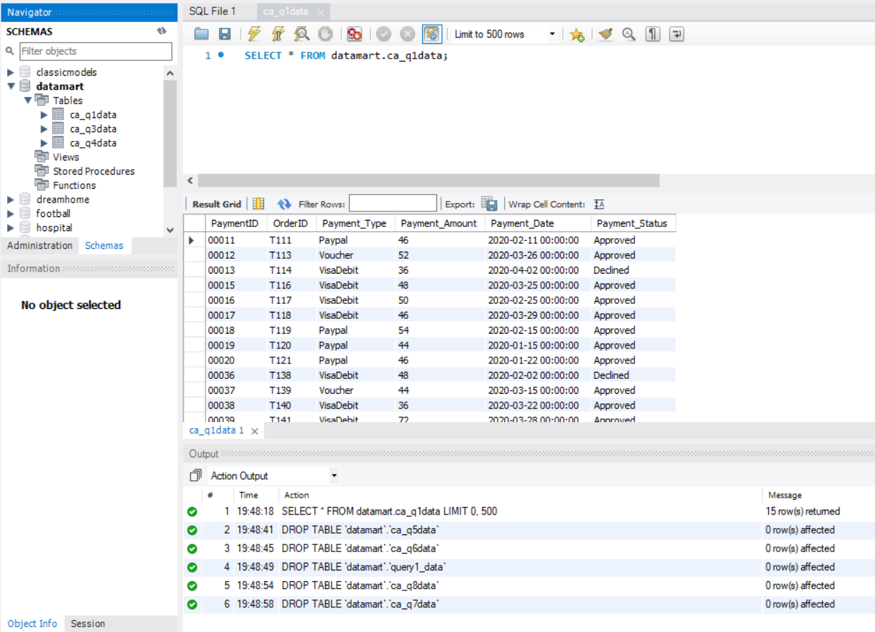

#### Excel graph

|  |  |
| --- | --- |
| **Payment Type** | **Time of payments** |
| PayPal | 4 |
| Visa Debit | 9 |
| Voucher | 2 |
| **Grand Total** | **15** |
|  |  |

## Q2 Create a trigger that represent the stock levels when a sales order takes place

Step 1. Create a new Stock_audit table within Krie to prepare for the trigger

**Code**

USE Krie;

Create table stock_audit(

ProductID int,

Product_Name varchar(255),

Product__Stock_Level numeric(65),

changedon datetime,

action varchar(255)

);

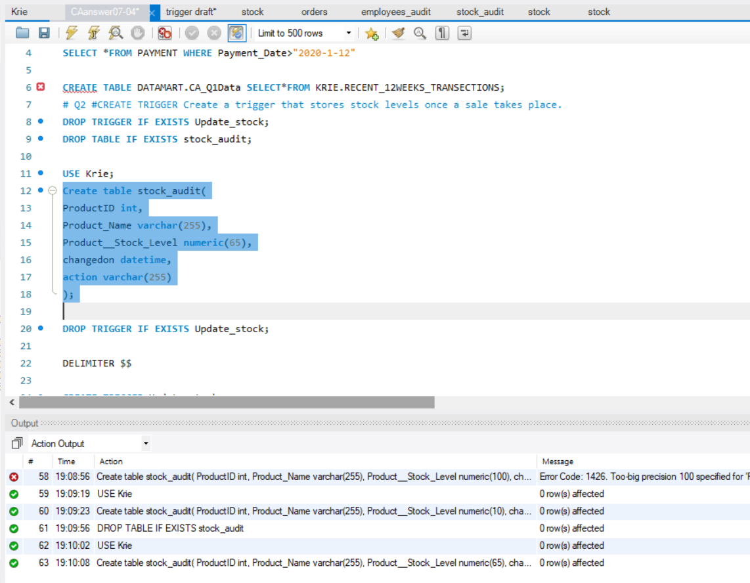

Step 2. Create a trigger

**Code**

DELIMITER $$

CREATE TRIGGER Update_stock

BEFORE UPDATE ON Stock

FOR EACH ROW BEGIN

INSERT INTO stock_audit

SET action='update',

ProductID=OLD.ProductID,

Product_Name=OLD.Product_Name,

Product__Stock_Level=OLD.Product__Stock_Level,

changedon = NOW();

END$$

DELIMITER ;

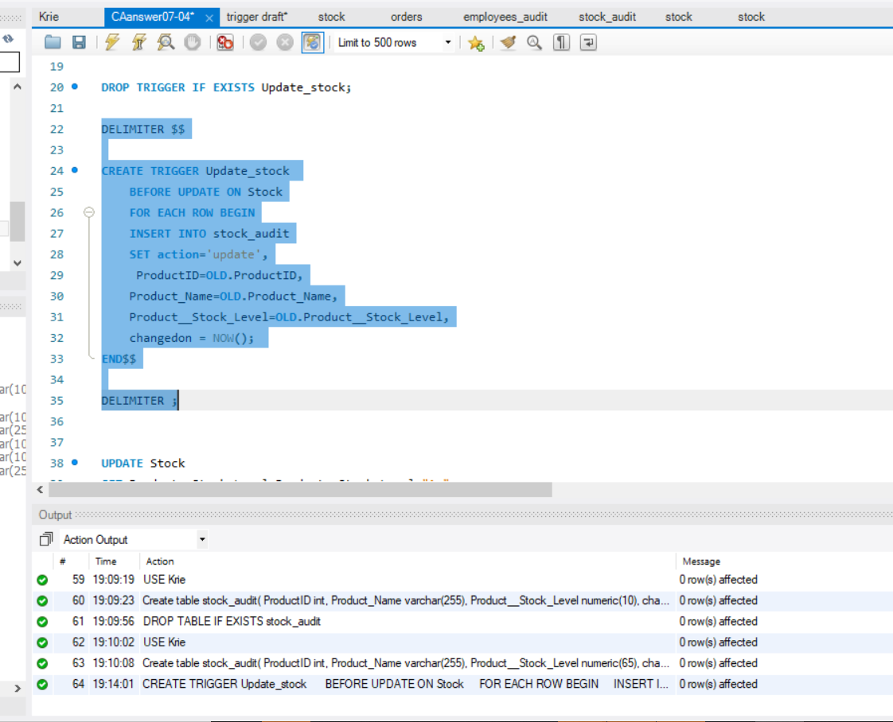

Step3. Check on if this is working correctly

* Product No.18 has 15 units in stock

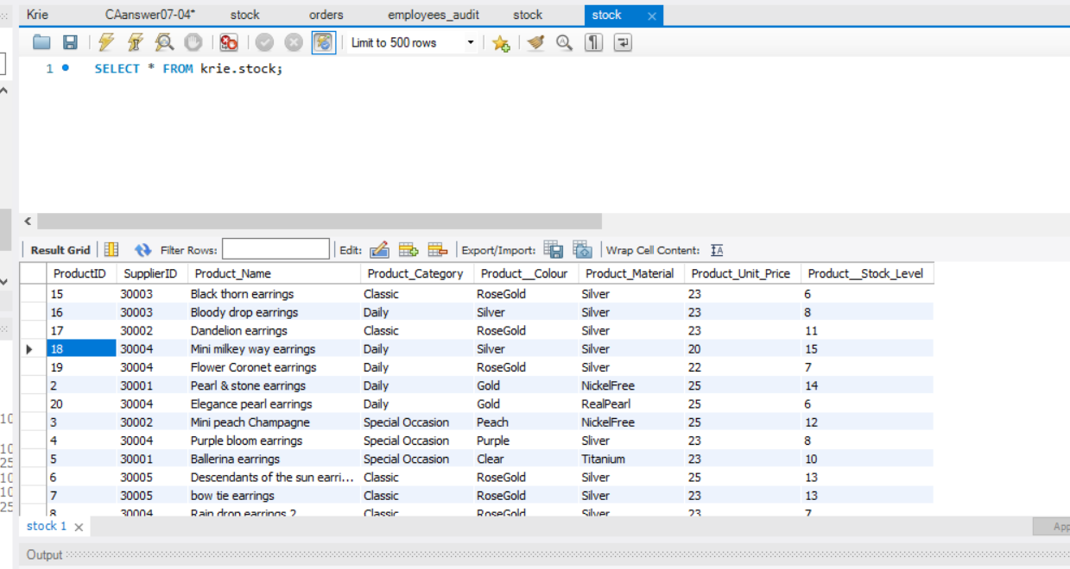

* Take away 2 units from No.18 from stock

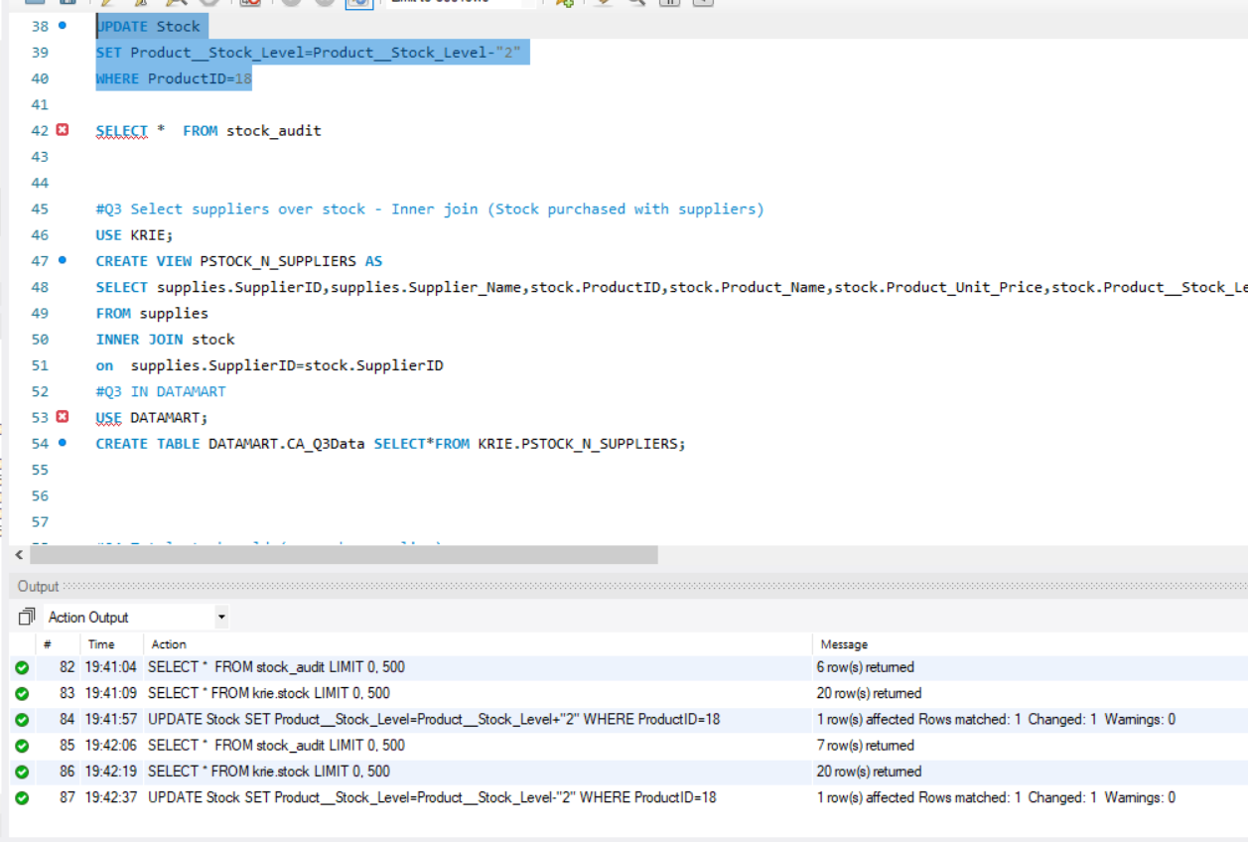

* Check on stock edit record

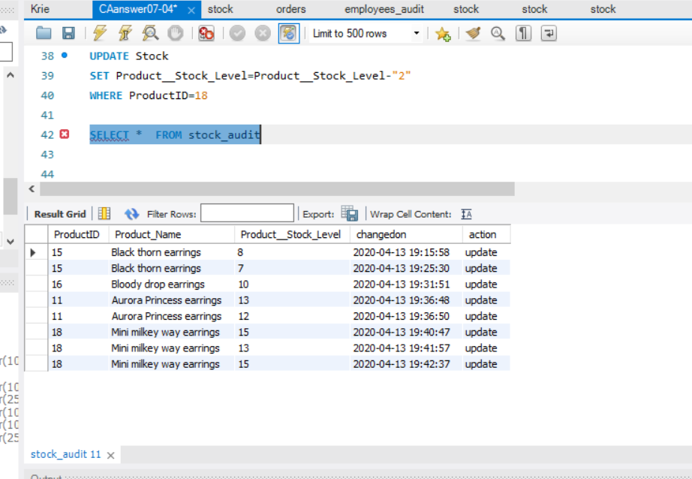

* Current stock level for No.18 is 13 units after updated

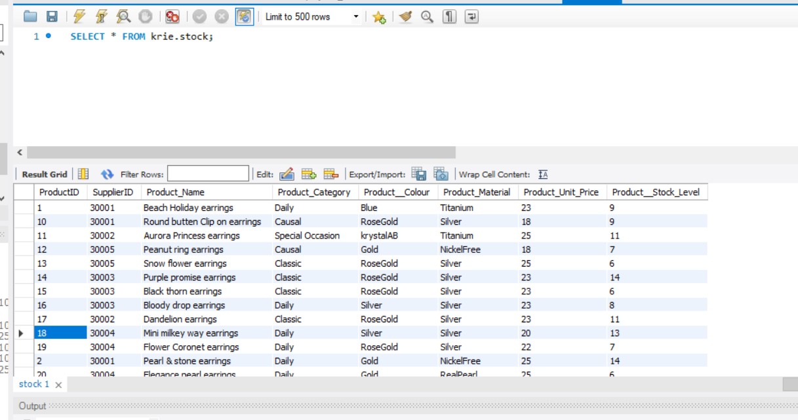

## Q3 Purchased stocks from suppliers

**Code**

CREATE VIEW PSTOCK_N_SUPPLIERS AS

SELECT supplies.SupplierID,supplies.Supplier_Name,stock.ProductID,stock.Product_Name,stock.Product_Unit_Price,stock.Product__Stock_Level

FROM supplies

INNER JOIN stock

on supplies.SupplierID=stock.SupplierID

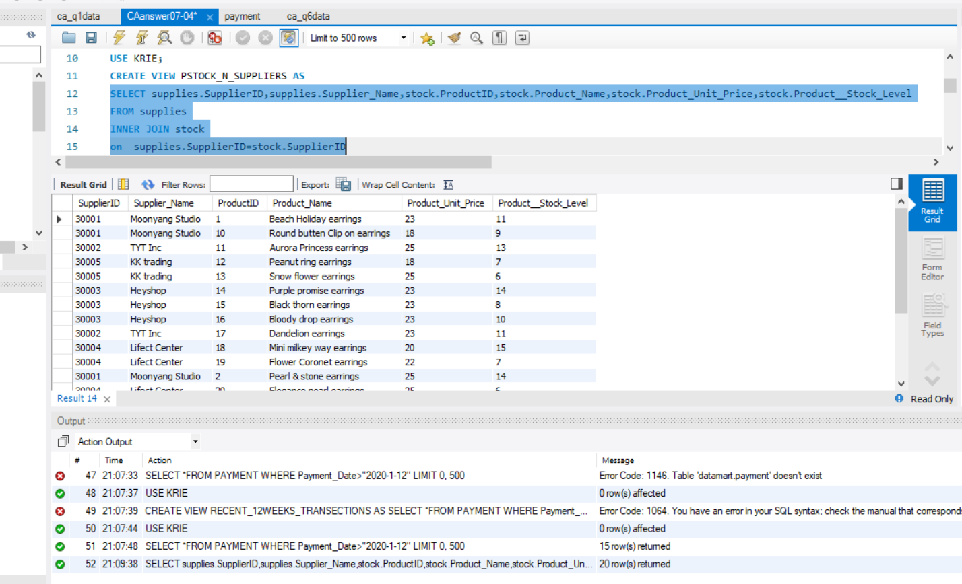

### In DataMart

**Code**

CREATE TABLE DATAMART.CA_Q3Data

SELECT*FROM KRIE.PSTOCK_N_SUPPLIERS;

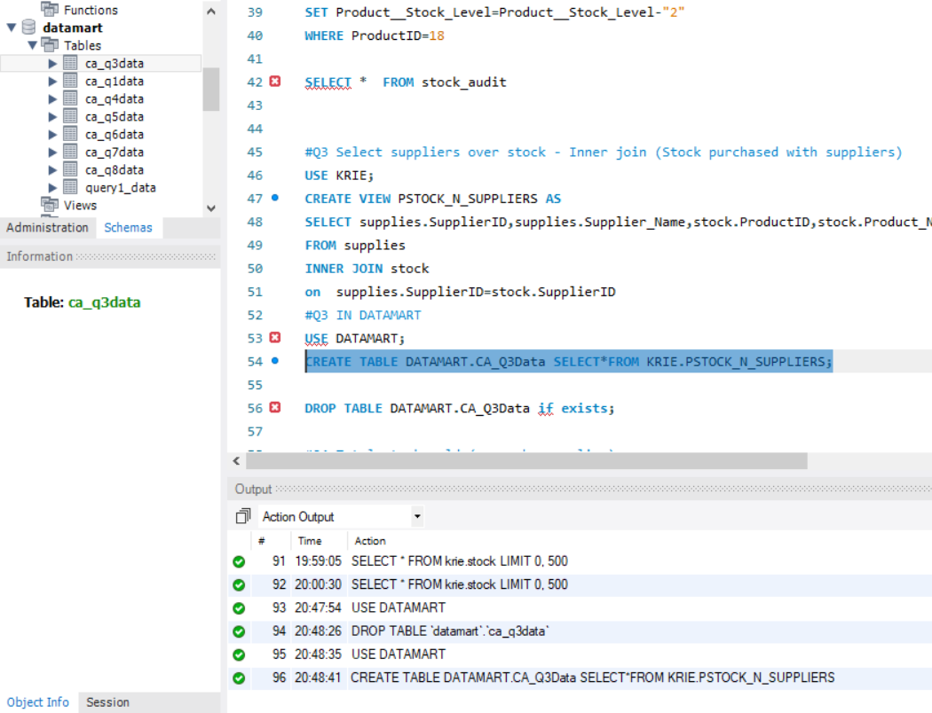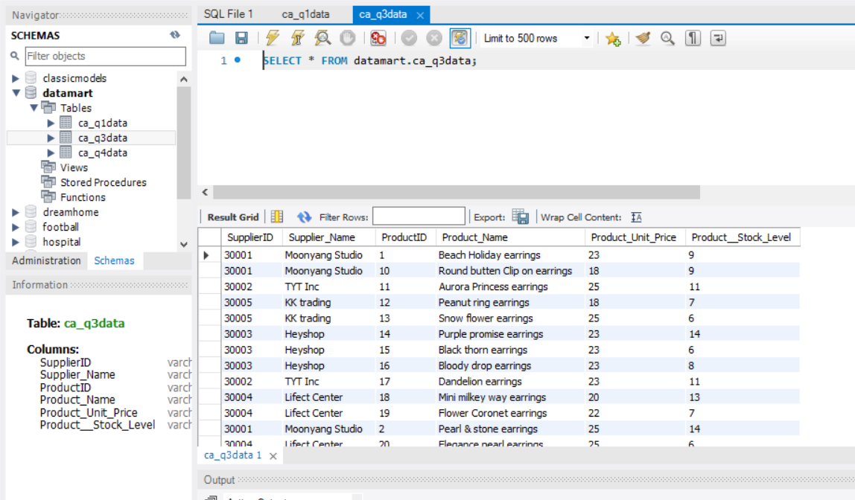

#### Excel Graph

A combine Chart to show more in details

## Q4 Total stock sold to general public (group by supplier)

**Code**

CREATE VIEW TOTAL_STOCK_SOLD AS

SELECT SUM(Ordered_units) AS "TOTAL STOCK SOLD" FROM orders;

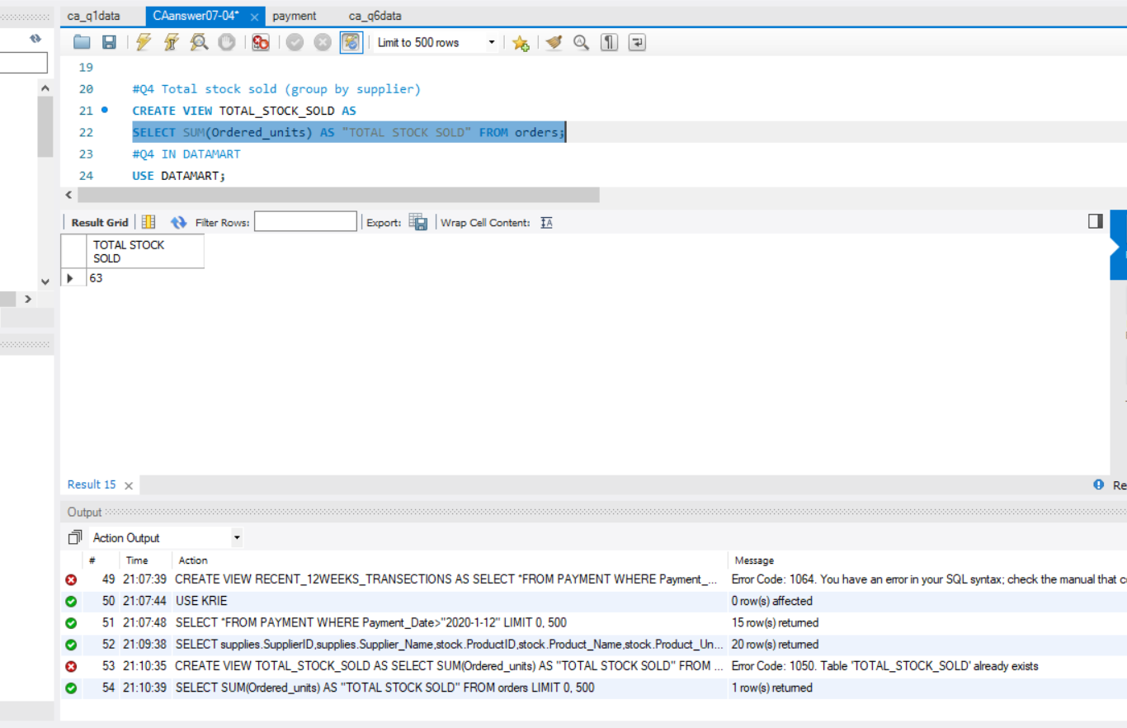

#### In DataMart

CREATE TABLE DATAMART.CA_Q4Data

SELECT*FROM KRIE.TOTAL_STOCK_SOLD;

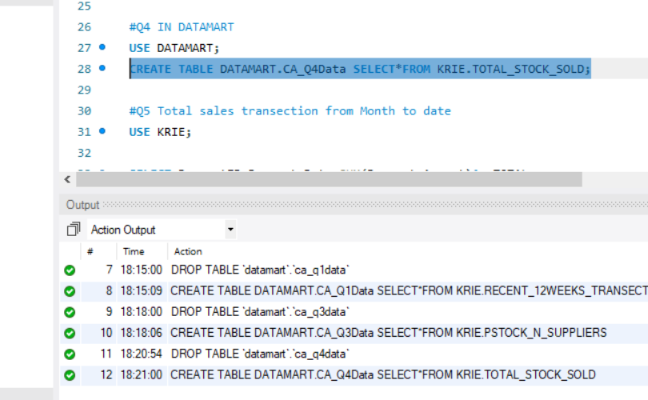

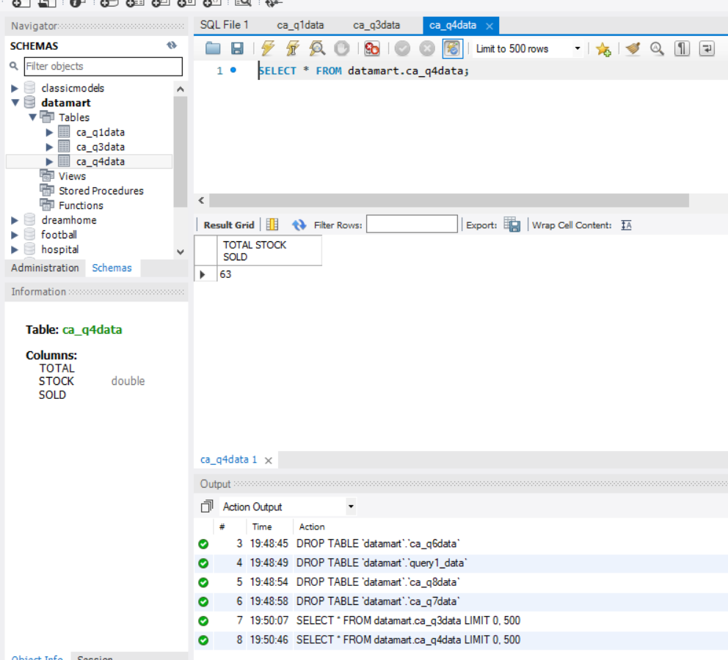

## Q5 Total Sales transection month to date (start from March)

**Code**

USE KRIE;

CREATE VIEW Q5TOTALSALES_MONTHTODATE_2020 AS

SELECT PaymentID,Payment_Date,SUM(Payment_Amount)As TOTAL

FROM Payment WHERE Payment_Date>"2020-02-29"

GROUP BY PaymentID,Payment_Date WITH ROLLUP

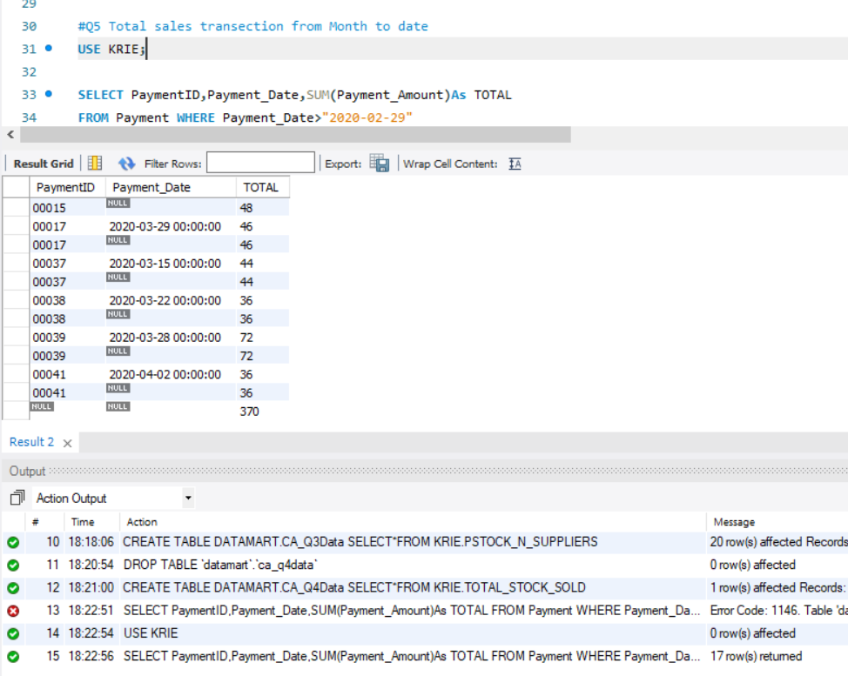

## Q6. Total Sales transection year to date 2020

**Code**

SELECT PaymentID,Payment_Date,SUM(Payment_Amount)As TOTAL

FROM Payment WHERE Payment_Date>"2019-12-31"

GROUP BY PaymentID,Payment_Date WITH ROLLUP

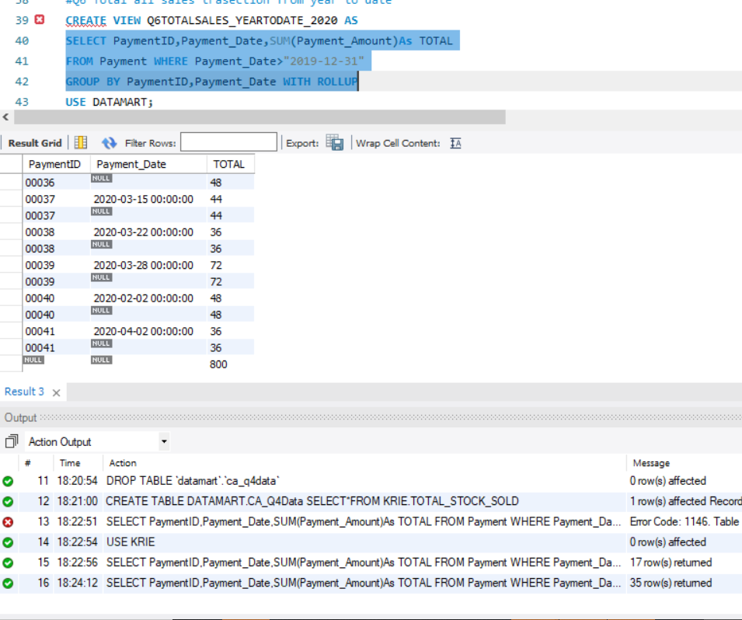

## Q7. Monthly breakdown for 2019

**Code**

select year(Payment_Date) as Year,

month(Payment_Date) as Month,

count(*) as Total,

SUM(Payment_Amount)As TOTALSALES

from Payment where year (Payment_Date)=2019

Group by year(Payment_Date), month(Payment_Date) with rollup

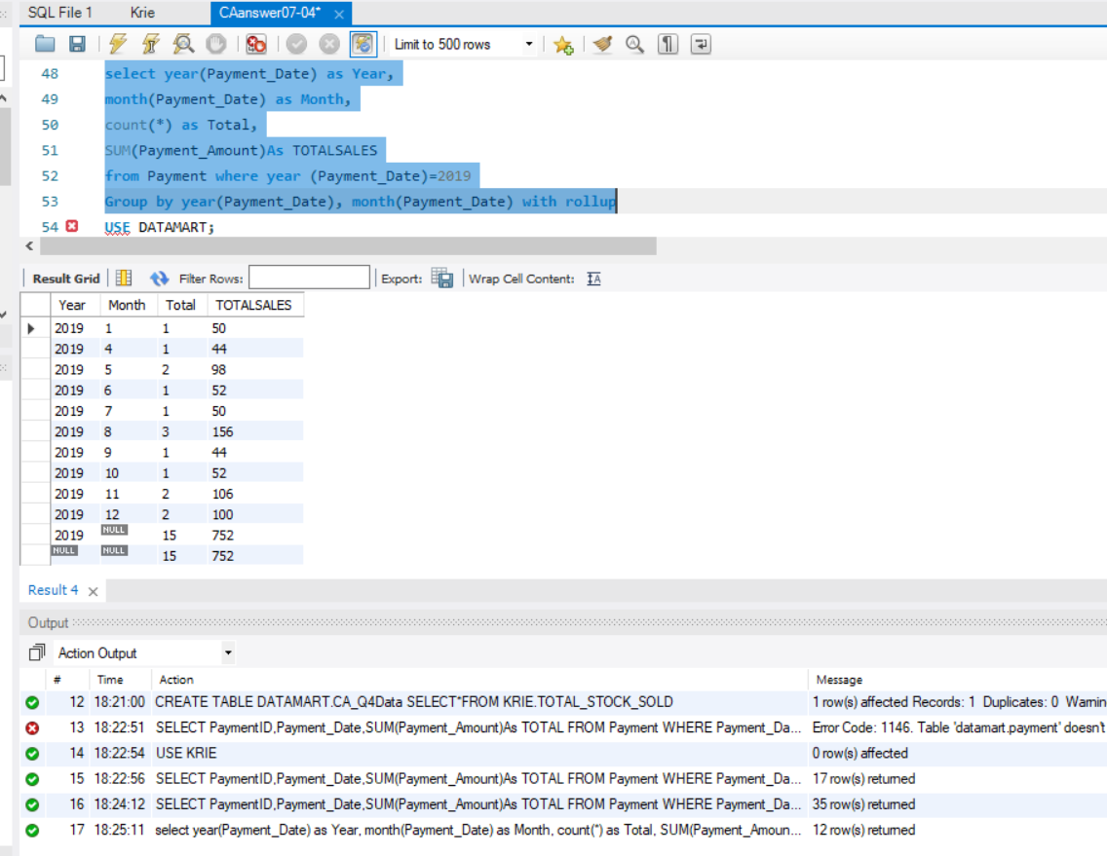

## Q8. Growth rate % from 2019 to now

**Code**

SELECT 2019 AS Year,((800-752)/752)*100 As GROWTH_RATE_2020

6.38% is the growth rate for this business

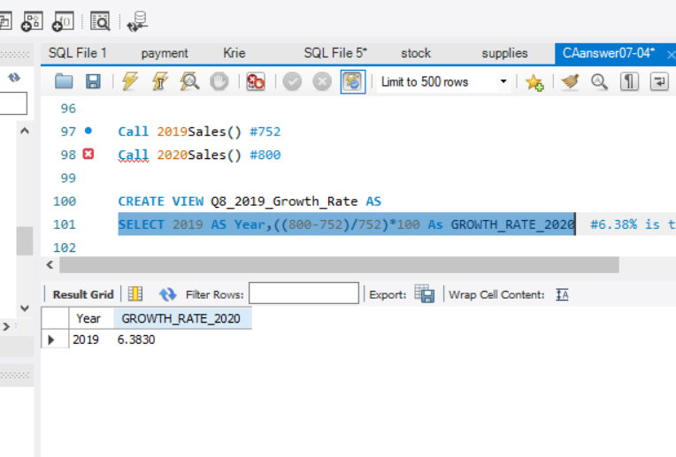

## *Additional* - Stored procedures

# Sales 2019 and 2020

**Code**

select year(Payment_Date) as Year,

month(Payment_Date) as Month,

count(*) as Total,

SUM(Payment_Amount)As TOTALSALES

from Payment where year (Payment_Date)=2020

Group by year(Payment_Date), month(Payment_Date) with rollup

DELIMITER //

CREATE PROCEDURE 2019Sales()

BEGIN

select year(Payment_Date) as Year,

month(Payment_Date) as Month,

count(*) as Total,

SUM(Payment_Amount)As TOTALSALES

from Payment where year (Payment_Date)=2019

Group by year(Payment_Date), month(Payment_Date) with rollup;

END//

DELIMITER //

CREATE PROCEDURE 2020Sales()

BEGIN

select year(Payment_Date) as Year,

month(Payment_Date) as Month,

count(*) as Total,

SUM(Payment_Amount)As TOTALSALES

from Payment where year (Payment_Date)=2020

Group by year(Payment_Date), month(Payment_Date) with rollup;

END//

Call 2019Sales() #752

Call 2020Sales() #800

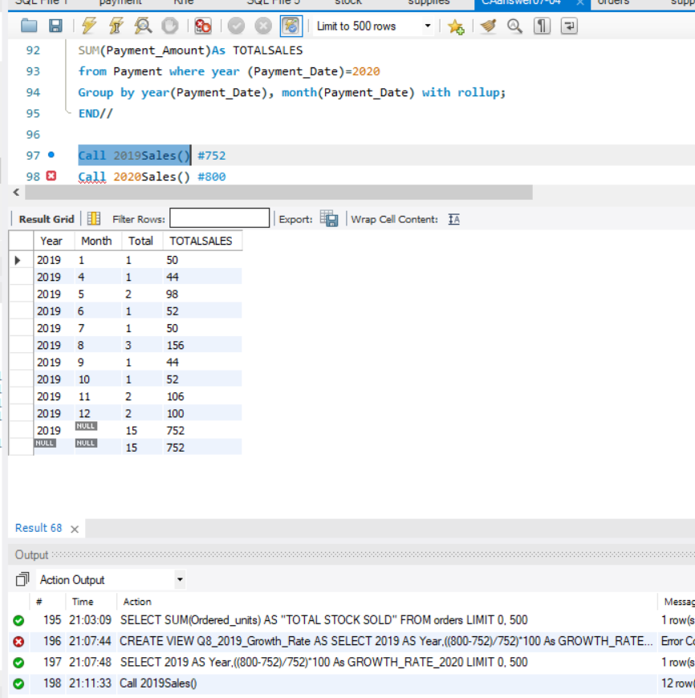

# References

Society programmer, (2018), Abstract SQL database monthly data [Online], Available at:

<https://blog.csdn.net/ao123056/article/details/79443788>

[Accessed on 16-April-2020]

MDCCL, (2018), stock quantity trigger [Online], Available at:

<https://dba.stackexchange.com/questions/204363/stock-quantity-trigger>

[Accessed on 17-April-2020]